EX.NO: 02 Identify a Business and Create a website to Implement

Digital Marketing

# Type of my Business:-

Joe Xbox store is your ultimate destination for all things gaming. Immerse yourself in a world where gaming enthusiasts unite to explore a vast collection of video games across genres, platforms, and generations. At Joe Xbox store, we don't just offer games – we offer an unparalleled gaming experience. Discover a treasure trove of both classic titles and the latest releases, carefully curated to cater to every gamer's preferences.

But that's not all. We go beyond gaming sales, offering expert repair services to ensure your gaming equipment stays in prime condition. From console repairs to controller fixes, our skilled technicians are dedicated to reviving your gaming gear, getting you back in the action without missing a beat.

What truly sets us apart are the expansive possibilities we provide for gamers. Dive into a world of weekly memberships, early access to new releases, exclusive in-game content, and a thriving community of fellow gamers. Unlock your gaming potential with special discounts, virtual currency boosts, and unique challenges designed to elevate your skills. At Joe Xbox store, we're not just a store – we're a haven for gamers, a place where passion meets innovation, and where every player finds their gaming haven.

# The business model

The Joe Xboxstore business model is a dynamic blend of product sales, repair services, membership subscriptions, and community engagement. It thrives by selling a diverse range of video games for various platforms while also offering repair solutions for gaming equipment. A unique weekly membership subscription delivers exclusive benefits like early game access and virtual currency boosts. The store taps into in-game purchases with special content offerings and fosters a strong gaming community. Strategic partnerships, cross-promotion, and continuous innovation further solidify its position as a comprehensive gaming hub.

# Type of product or service offered:-

Products:

Video Games: A diverse collection of video games spanning genres, platforms, and generations, catering to a wide audience of gamers.

Consoles: Gaming consoles from leading brands, providing players with options to enjoy their favorite games on high-quality hardware.

Services:

Repair Services: Expert repair solutions for gaming gadgets, including consoles, controllers, and accessories, ensuring uninterrupted gaming experiences.

In essence, the company provides an extensive selection of video games and gaming consoles for purchase, along with specialized repair services to address any technical issues that gamers might encounter.

# The brand

The Joe Xboxstore brand is a haven for gamers, offering a captivating fusion of gaming products and services. With a vibrant array of video games spanning genres and platforms, coupled with an assortment of cutting-edge gaming consoles, we empower players to embark on unforgettable gaming journeys. Our commitment extends beyond product offerings – our skilled technicians provide expert repair services to keep your gaming gear in prime condition. At Joe Xboxstore, we epitomize the spirit of gaming, embodying a community where passion, innovation, and seamless experiences converge.

# The target audience

The target audience of Joe Xbox Store includes casual and hardcore gamers, families, tech enthusiasts, competitive players, collectors, community-driven gamers, gaming parents, nostalgia seekers, and gaming enthusiasts. The store caters to a wide range of individuals who share a passion for immersive gaming experiences, offering diverse products, services, and community engagement opportunities to meet their distinct preferences and needs.

# Webpages:

Login Page:-

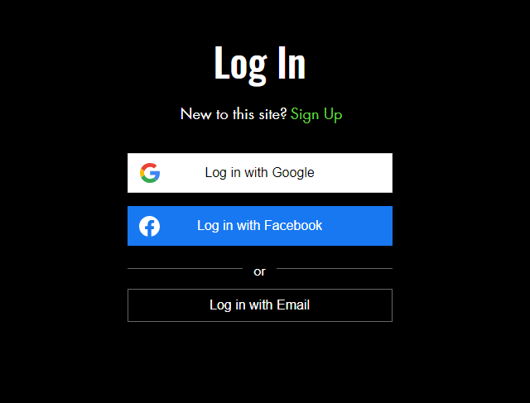

Home page:-

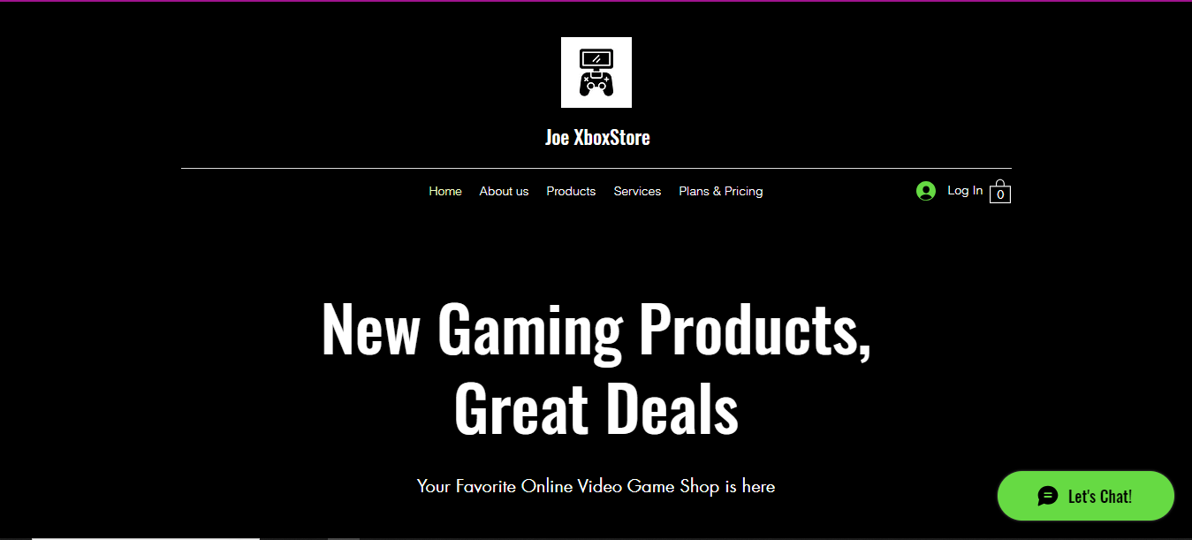

About us:-

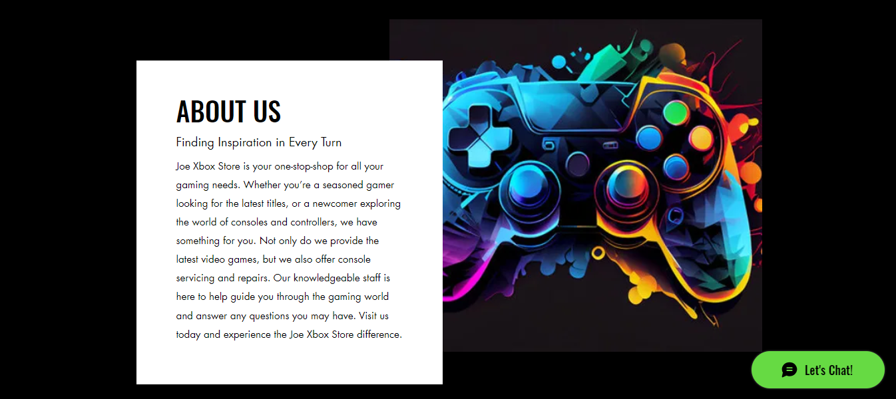

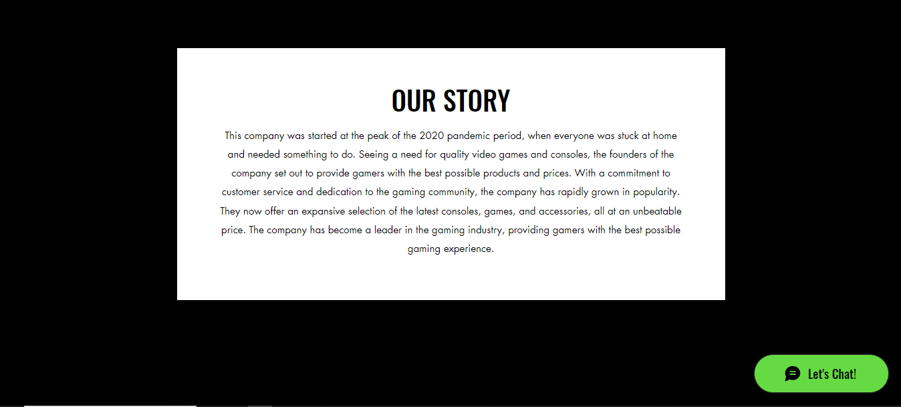



Products:-

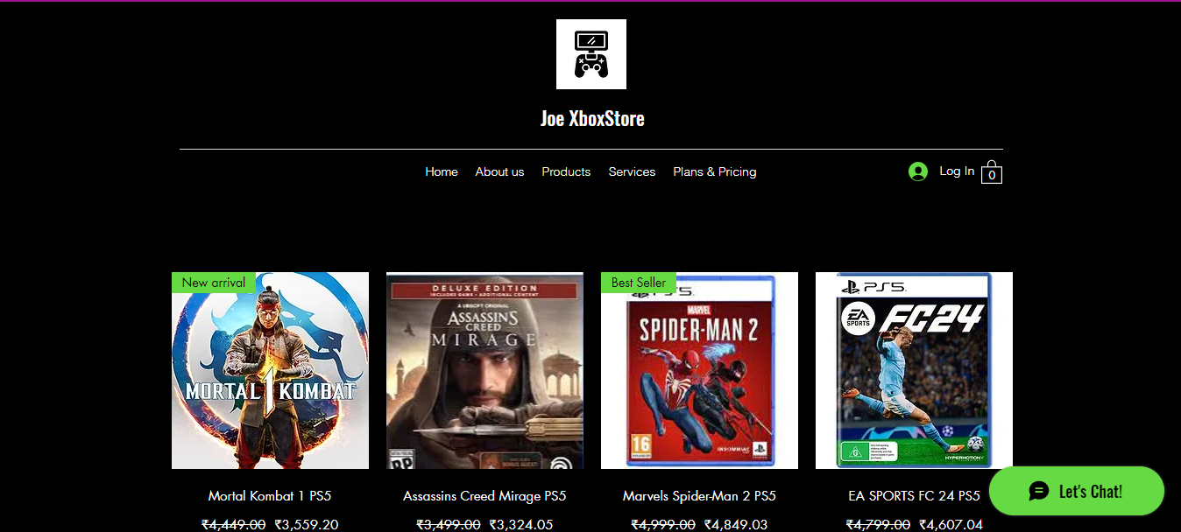

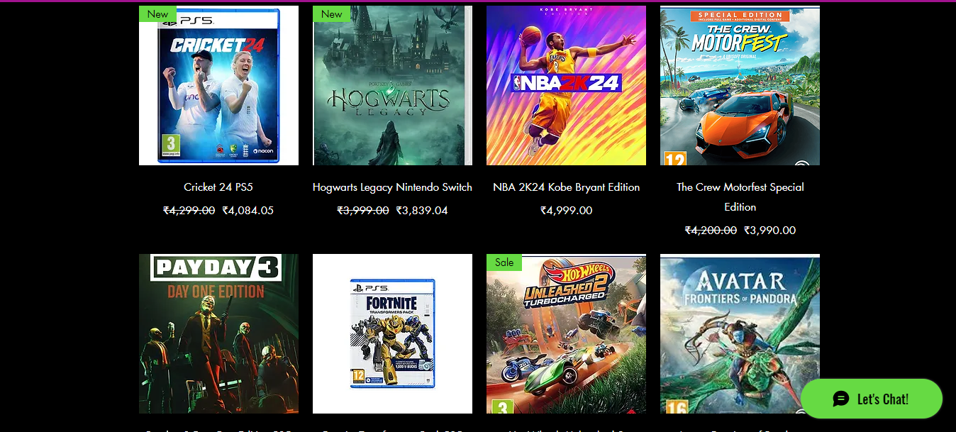

Landing page of the Product:-

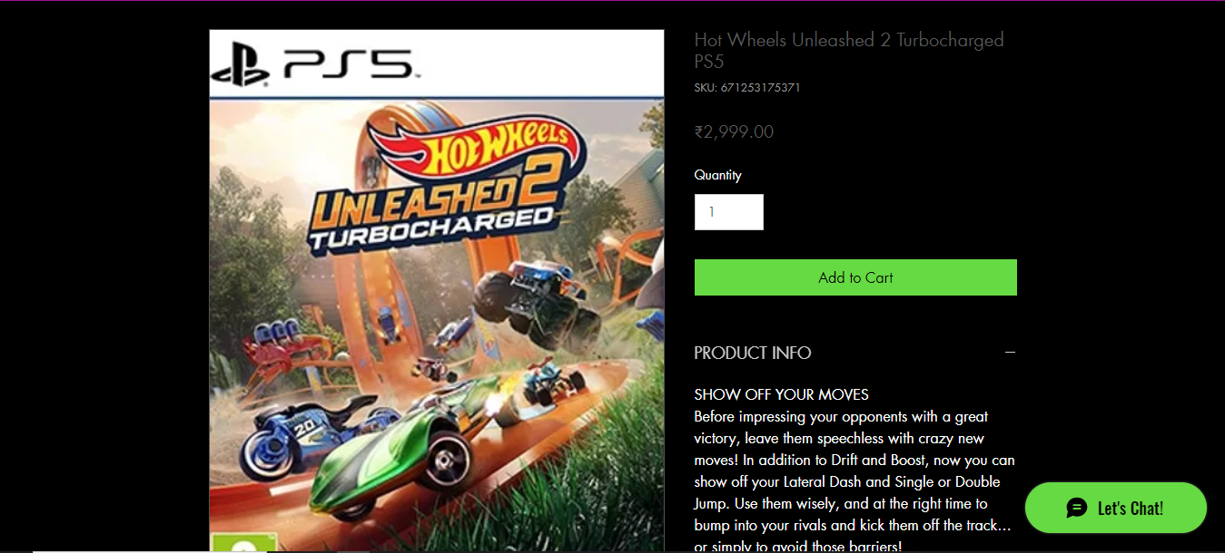

Services:-

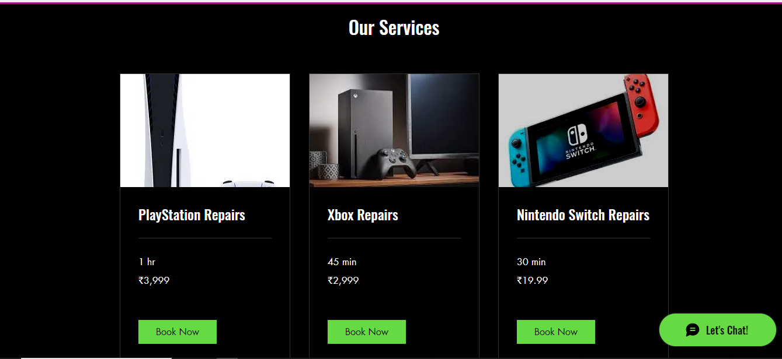

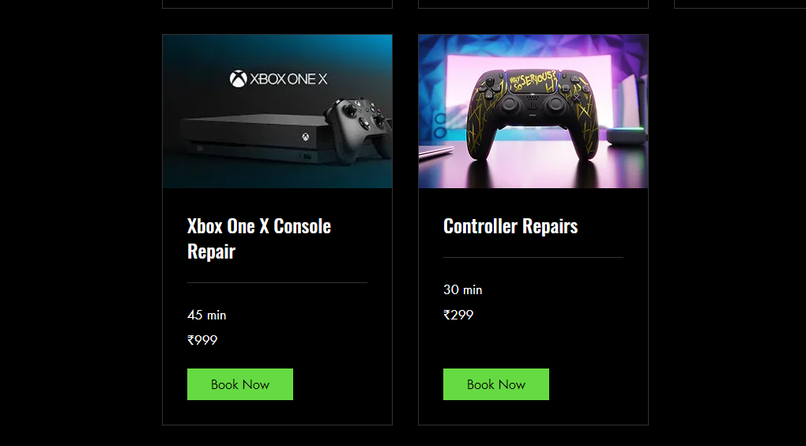

Plans and Subscription:-

